**Structure of Bee Communities in Marginal Lands of the Puget Sound, USA**

Evan Sugden1*, Will Peterman2, Robert Redmond3, Riley M. Anderson4, and David W. Crowder4

1 Entomo-Logic, Salt Lake City, UT, USA, ZIP??

2 Bee Search, Seattle, WA, USA, ZIP??

3 The Common Acre, Seattle, WA, USA, ZIP?? (deceased)

4 Department of Entomology, Washington State University, Pullman, WA, 99164

* Correspondence: evan@entomologic.com

**ABSTRACT**

Wild bee communities in urban ecosystems are often challenged by habitat fragmentation and low floral diversity. In such settings, relatively unused land surrounding airports or in power line corridors may support bees, even with small habitat patches. However, relatively long-term surveys of wild bees are lacking for many urban areas such as the Puget Sound region of western Washington State, USA. Here, we conducted wild bee surveys at three peri-urban sites in the Puget Sound region over a period of 7 years. Specifically, a standardized protocol was used to sample wild bee communities monthly from April to October at two sites associated with airports and one site in a power line corridor. In total, our surveys collected 25,441 specimens representing 118 confirmed species within 24 genera, with individual sites having between 15 and 35 species in any given year. The Halictidae had the most individuals collected, with 47% of specimens, *Lasioglossum* the most speciose, and *Bombus*, *Osmia*, and *Andrena* also ubiquitous and diverse. Bee diversity was high across spring and summer, and the phenology of parasitic taxa appeared to overlap with their hosts. Our study suggests marginal lands requiring little management can support diverse wild bee communities in urban areas. Our work also provides a baseline for future evaluations of wild bee communities in the Puget Sound and broader Pacific Northwest.

**Keywords:** Airport, conservation, fragmented landscapes, restoration, pollinators, power line corridor, urban ecosystems

**INTRODUCTION**

Wild bee communities are impacted by abiotic conditions as well as availability of nectar, pollen, and nesting resources (REFS). As natural habitats are lost to urbanization and agriculture, bees lose resources, leading to population declines (REFS). Yet, not all wild bee species are equally impacted by alterations of habitat, including restoration efforts on degraded lands (REFS). To aid pollinator assessment and conservation, studies are needed to assess how different forms of habitat restoration impact bee community structure. Given that the dynamics of bee communities and their local floral resources can be highly ephemeral, capturing temporal trends within and across seasons may be particularly valuable (Bloom et al. 2023). Such studies can also provide a baseline of species diversity and abundance to guide future evaluations.

SPACE FOR REFS

Urban and peri-urban habitats present unique challenges for bees due to the large amount of impervious surface, which eliminates ground-nesting, combined with extreme fragmentation of resources (REFS). Efforts to restore bee communities in urban areas has taken many forms, such as the restoration of urban lots into pollinator-friendly spaces with diverse native flowering plants that provide continuous food resources (REFS). Government-leased lands, such as parks and utility corridors, can also be used for pollinator meadows, which not only increases floral diversity but also establish nesting substrates that are key for solitary bees (REFS). Specific practices, like minimizing lawn mowing or incorporating green roofs, improve habitat quality while enhancing ecological connectivity in fragmented urban landscapes (Turo & Gardiner, 2019). By leveraging government land for habitat restoration, cities can create interconnected networks of pollinator refuges, fostering urban biodiversity and ecological resilience.

SPACE FOR REFS

Efforts to restore bee habitat in urban areas have recently focused on restoration of airports, with Chicago O’Hare, Detroit Metropolitan, and Seattle-Tacoma Airport examples of sites that have turned underused land into bee habitat (REFS). There is often considerable land around airports given the need for undeveloped space for planes, and land that was formerly used for airports that have been de-commissioned may also provide habitat. However, it is unclear how restoration of airports may affect different bees that vary in seasonality and resource requirements. Further, understanding how restored airports compare to other habitats is key to determine if restorations can support diverse and robust bee communities (REFS). These knowledge gaps highlight the need for continued research to refine habitat restoration strategies and maximize their effectiveness in both airport environments and broader urban landscapes.

SPACE FOR REFERENCES

Our study evaluated the diversity and structure of wild bee communities in marginal lands of western Washington State, USA. Bee diversity of western Washington has remained largely undescribed, except for a few recent studies on farm, garden, and parkland habitat (Bloom et al. 2021, 2023). Given the rapid urbanization of western Washington, assessments are needed to determine the status of common and rare species. To address this, we conducted monitoring over seven years at three sites in western Washington, two on airports and one that used government-leased land in power corridors. Our focus was to document the bee community structure in the study areas and the temporal dynamics of each species. We also assessed how bee communities varied within and across seasons. Our study provides a baseline for future evaluations of bee communities in western Washington and insight into whether restoration of government-leased airport and land beneath power lines can support robust and diverse bee communities.

**METHODS**

***Study System***

Our surveys of wild bees were conducted at three sites in the lower Puget Sound region in western Washington State, within a few miles of the major cities of Seattle (two sites) or Everett (one site). Although sites were unique, they were similar in their proximity to development, past history of disturbance, and largely weedy nature of the vegetation. The three sites and the years monitored were: (i) Port of Seattle (SeaTac Airport) (2014-2020), (ii) Boeing Paine Field (airport facility) (2018-2020), and (iii) Seattle City Light (power corridor) (2016-2018). Our surveys assessed the diversity and community structure of wild bees within and across seasons.

***Study Site Descriptions***

The Port of Seattle site is 3 km south of the airport runways on land serving as a security buffer zone. In the mid-20th century it was also used as a golf course, components of which are still recognizable (e.g., sand traps). The vegetation is varied and weedy, with patches of past revegetation, wild Himalayan blackberry (*Rubus aermeniacus*), knapweed (*Centaurea* sp.), wild mustard (*Brassica* spp.), and big leaf maple (*Acer macrophyllum*) common species. Open areas with low perennial or annual weedy plants provided the main collecting habitat. Trap sites were separated by a few hundred meters, and two apiaries with up to 10 colonies within 1 km.

Boeing Paine Field is 10 km SW of Everett, WA. Habitat included low-maintenance lawn and meadow to riparian, all surrounded by a narrow corridor of red alder (*Alnus rubra*). Beyond the site, the landscape is composed mainly of suburban development and airport parking lots and runways. This site is 1 km from the Puget Sound and experiences maritime influence. This site, trapped from 2018-2020, consisted of 5 stations with separations of between 50 and 500 m.

The Seattle City Light site is a power corridor 10 km southeast of Seattle, and consisted of 5 trap stations 2 km apart: (i) a semi-managed meadow- habitat in Rainier Beach neighborhood, (ii) a semi-boggy slope descending toward the interstate, (iii) the bounds of a weedy equipment storage pad North of the Duwamish Hill Preserve, (iv) the banks of the Duwamish River between a road and a power transfer facility, and (v) a site near a power station (only sampled in 2016).

***Bee Surveys***

Trap stations consisted of uniform linear arrays of 15, 15-cm plastic Solo cups, placed in 5 clusters of 3 each; each cluster had one blue, one yellow, and one white cup. These large cups were replaced in 2016 with identically-painted 4 oz. “mini-cups”. The cups were accompanied by 3 equally-spaced “blue vane” traps (BanfieldBio, Woodinville, WA) with original fluorescent yellow jars. However, due to the potential presence of the threatened *Bombus occidentalis* at the Boeing Paine Field site, we only used one blue vane trap per array. Traps were placed at each site once per month from April to September, with arrays placed between 08:00 and 10:00 and left for 24 hours before collection. Trap collecting was supplemented with net collecting on an opportunistic basis (Turley et al. 2024). The method used was sweeping with a heavy 15-inch sweep net bag and the standard measurement of effort consisting of 100 sweeps.

Specimens from traps were removed by pouring the trap fluid through a fine strainer and placing bees into vials filled with 70% ethanol; net-collected specimens were dispatched with ethyl acetate and placed in blotter paper “layers” for storage. In the laboratory, specimens were then removed from alcohol and grouped taxonomically to the lowest level allowing certainty of identification to species or morphospecies, and sex was recorded when possible. Specimens were identified using published taxonomic papers, semi-technical guides, and online Discover Life keys. When we were unable to identify specimens ourselves professional assistance was sought from a number of specialists by sending them representative samples, or through personal visits to the USDA Pollinating Insects/Utah State University Bee Collection in Logan, UT to use the extensive collection there and consult directly with resident specialists. Similar help was also sought at the Bohart Museum of Entomology, University of California, Davis, CA. Specimens that eluded species identity were assigned morphospecies classifications that were unique.

***Statistical Analyses***

Riley stuff Still working on this…

**RESULTS**

***Bee community structure***

Across the three sites and seven years of the project we collected a total of 25,441 bee specimens. Of these specimens, 25,017 (98.33%) were identified to the species level, representing 118 species from five families and 24 genera. Of the remaining 424 specimens, 376 (1.48%) were identified to morphospecies, representing potentially 35 additional species within the genera: Nomada, Osmia, Sphecodes, and Triepeolus. The remaining 48 specimens (0.19%) were damaged, hindering species-level identification, however, these specimens were confidently identified to genus.

Our species accumulation curves did not reach asymptotes, suggesting that the 118 confirmed species likely underestimates the true richness across the three sites (Figure X). Chao richness estimation revealed the total richness across all sites and years as 139 species (using trap and net collected records). Using only trap records, Chao richness was estimated at 124 species. Chao richness for the individual sites, POS, SCL, and BPF was estimated using trap records only at 115, 92, and 80 species, respectively.

Species which were represented by a single specimen (“singletons”) have a disproportionate influence on some analyses, such as Chao richness and may have special significance regarding collecting technique, conservation, and biogeography (). Twenty of our recovered species (16.95% of total richness) were represented by singletons, which are listed in Table S1. In a similar vein, super-abundant species can reflect importantly on community structure and we therefore list in Table S2 the top 10 species by specimen representation. Breadth of distribution can be important in community considerations, so we also list in Table S3 those species that were collected in all three of our sites. Collecting technique and the importance of supplementing traps with net collecting is non-negligible. For example, we found 11 species collected only by net, representing 9.32% of total richness (Table S4). As males are often underrepresented in collections for various reasons we also list in Table S5, species for which we collected no males by either traps or netting. We collected a total of 575 records of *Apis mellifera*, representing 2.26 % (575/25441). Of the 575 *A. mellifera* specimens, 213 (37.04 %) were collected by net with the remainder in traps, mostly Blue Vane Traps. This study did not focus on documenting in detail the differences in trap function regarding bowl vs. Blue Vane or between various bowl colors. Anecdotally, however, we can report that Blue Vane traps excelled in collecting large bodied species and a greater diversity than bowl traps, yet the two trap types were complementary in function.

Our species accumulation curves did not reach asymptotes, suggesting that the 118 confirmed species is likely an underestimate of the true richness across the three sites (Figure X). Chao richness estimation suggests the minimum richness across all sites and years is 139 species (using trap and net collected records). Using only trap records, Chao richness was estimated at 124 species. Chao richness for the individual sites, POS, BPF, and SCL was estimated using trap records only at 115, 80, and 92 species, respectively (Fig. 1A). Within individual years, each site had between 15 and 40 unique species, with an estimated Chao richness estimated at between 35 and 70 species (Fig. 1B). These estimates suggest that in any year we likely captured between 30 and 70% of the total species present at each site. Our results also suggest that not all species were present in every year, and that only by collecting over multiple years did we gain a better estimate of the total diversity of the bee community (Fig. 1).

Across all sites and years, the distribution of specimens across taxa was highly uneven, with 47.01% of total individuals in the genus Halictus (Fig. 2A). However, this may reflect greater sampling effort at Port of Seattle, where Halictus was dominant (Fig. 2D), compared to the Boeing Paine Field and Seattle City Light sites, where Bombus was the most common taxa (42.80% & 26.10%, respectively) (Figs. 2E, 2F). The bias towards Halictus was more notable in specimens from traps (Fig. 2B) than nets, which had a more even distribution across genera (Fig. 2C). Although Halictus and Bombus accounted for the greatest abundance, Lasioglossum, Andrena, Osmia, and Megachile were far more speciose (Fig. 2). However, in general similar species were found at all of the sites, indicating that diversity was relatively conserved at the genus level across sites.

Species composition varied significantly across sites (PERMANOVA; *F*2 = 2.11, *P* = 0.005), with BPF hosting a statistically distinct bee community from the POS and SCL sites (Figure XX). Major changes in abundance primarily delineate the BPF site from the others. Notably, when compared to the POS and SCL sites, the BPF site had drastic reductions in *Halictus tripartitus*, *Agapostemon texanus*, *Apis mellifera*, and *Bombus fervidus*, and major increases in *Bombus melanopygus*, *Halictus confusus*, and *Bombus mixtus* (Table X). Moreover, our random forest model classified each site by species composition with an overall error rate of 15.38%. Error in the model is attributed to the overlap in species composition in POS and SCL sites. However, the BPF site was never misclassified (0.0% class error), lending further support that the BPF site was quantitatively different from the others in terms of species composition.

***Bee seasonal biology***

We assessed the seasonal biology of bee genera (Fig. 4) and species (Fig. 5) to assess the dynamics of species over time. The first bees to emerge were species in the genera Ceratina, Andrena, and Nomada; while Andrena and Nomada peaked in early spring Ceratina was found across the entire season (Figs. 4, 5). The genera Osmia and Lasioglossum, which were also highly common, also peaked in the spring and had a short yearly cycle (Figs. 4, S1). Other genera peaked in the summer months, including Sphecodes, Melissodes, Megachile, Bombus, Apis, Hylaeus, and Halictus (Figs 4, S1). At the genera level, multimodal distributions likely represent multiple species, as well-defined multimodality was rare at the species level, with most species reaching a single peak abundance before tapering off throughout the season. We caution that small peaks observed in the distributions may arise from structured sampling events, rather than true biological phenomena. Nevertheless, that major abundance peaks are detectable given the non-random noise of sampling events suggests that our data capture the true seasonal maxima of these species. These results show substantial turnover within seasons, but diverse communities exist throughout the year.

When looking at common parasitic genera, we found major overlap in phenology with their presumed hosts. For example, Nomada parasites peaked in the spring at a similar time as their hosts Andrena and Agapostemon (Fig. 5A), and Coelioxys parasites peaked in summer at the same time as their Megachile hosts (Fig. 5C). However, while Sphecodes strongly overlapped with Halictus, two other presumed hosts (Agapostemon and Lasioglossum) tended to be active earlier in the season (Fig. 5B). Although we did not have enough specimens to reliably estimate the phenology of three other parasites (Stelis, Epeolus, Triepeolus), preliminary estimates of overlap between these species and their presumed hosts are shown in Fig. S2.

**DISCUSSION**

Our study shows a diverse community of wild bees persists in relatively marginal habitats of the lowland Puget Sound region of western Washington State, USA. We captured a total of 118 species across 24 genera, which exceeds the 109 species across 21 genera found in prior surveys of western Washington diversified farms and gardens (Bloom et al. XXXX, XXXX). Although the genera captured across both studies were largely consistent, we likely found more species due to our monthly sampling that spanned April to October compared to sampling three times a year (Bloom et al. XXXX, XXXX). It is also possible that the greater number of species found in our sites reflected largely weedy compared to managed floral communities, or because management of farm sites may have limited floral resources for bees.

Our study provides evidence that marginal lands in urban areas, such as airports and power line corridors, support diverse wild bee communities. These often underused spaces provide an opportunity to support biodiversity while minimally interfering with the primary function of the land. Airports often have extensive grassy perimeters, and restoring native plants into these areas while reducing mowing may create suitable habitat for bees (Linz et al., 2021; Gallé et al., 2022). Similarly, power line corridors are often cleared of large vegetation, and can be transformed with flowering plants to support bees (Wojcik & Buchmann, 2012; Russell et al., 2018). These efforts may enhance pollination services for nearby green spaces and urban farms while also promoting broader sustainability and community development (Rundlöf et al., 2015; Hall et al., 2017). Our results provide further evidence that marginal lands may provide a key tool for urban pollinator restoration, especially given that little to no maintenance on the land is required.

Efforts to conserve bees in fragmented urban landscapes extend beyond airports and power lines. For example, community gardens provide a diverse range of flowering plants throughout seasons and often support pollinator diversity that is similar to nearby natural areas (REFS). Vacant lots in urban areas can also be managed to support pollinators by creating nesting sites and implementing low-maintenance landscaping (REFS). These interventions not only provide forage and shelter for pollinators but also contribute to community engagement. Similarly, by reducing mowing in roadside verges, these government-owned spaces can connect fragmented green spaces, facilitating bee movement and population growth. Our study complements this research and shows that allowing spontaneous vegetation growth in small urban areas supports pollinator diversity by offering a variety of flowering plants and nesting habitat.

Our results also show that diverse communities of bees were present across the season, although composition of communities changed over time. The phenology of bee species can be impacted by many factors such as life history, climate niche, and ecological interactions. Similar to other studies, we show that bees such as Nomada and Andrena are the first to emerge in early spring, aligning with flowering of early-blooming plants (REFS). As the season progresses, the activity of genera such as *Halictus* and *Lasioglossum* become more prominent. These genera are often more heat-tolerant and exhibit a broader range of nesting and foraging behaviors (REFS). In contrast, large-bodied genera like *Apis and Bombus* show prolonged activity, maintaining their colonies throughout the entire growing season, likely by exploiting a wider variety of floral resources (REFS). Our study provides a better understanding of the phenology of bees in the Puget Sound, and future work should consider how these patterns overlap with flowering plant phenology.

Our study also revealed phenology of parasitic bee groups and their hosts, although data was sparse for several taxa. Parasitic taxa such as *Nomada* and *Coelioxys* rely on phenological synchronization with their hosts to ensure access to nests and brood for parasitism. For example, *Nomada* often parasitizes *Andrena* bees, which emerge in early spring, whereas *Coelioxys* may target *Megachile* bees active during late spring and summer (REFS). Despite the ecological importance of these interactions, data on parasitic bees are limited. Many parasitic bees are less abundant than their hosts, and their cryptic behavior makes them hard to observe. Enhanced monitoring, targeted ecological studies, and integration of parasitic bees into broader pollinator research are essential to fill knowledge gaps on the roles of these key species.

CONCLUSION

**ACKNOWLEDGEMENTS**

We thank T. Griswold, H. Ikerd, D. Cox-Foster, J. Strange, J. Gibbs, G. Gardner, R. Thorp, and K. Koyamatsu for assisting in specimen identification, and C. Looney, E. Rare, A. Rinard, N. Mengist, and T. London for logistical support. Field site access was provided by Seattle City Light, The Port of Seattle, and Boeing Corp. Funding was provided by the Bullitt Foundation. We would like to recognize our junior author and colleague, Robert Redmond, now deceased, for his creative vision and facilitation, without which this work would not have been possible.

**LITERATURE CITED**

Aizen MA, Feinsinger P (1994) Habitat fragmentation, native insect pollinators, and feral honey bees in Argentine ‘Chaco Serrano’. Ecol Applications 4:378–392

Bloom, EH, EC Oeller, RL Olsson, MR Brousil, RM Schaeffer, S Basu, Z Fu, DW Crowder. 2022. Documenting pollinators, floral hosts, and plant–pollinator interactions in U.S. Pacific Northwest agroecosystems. Ecology 103:e3606.

Bloom, EH, JG Illan, MR Brousil, JP Reganold, TD Northfield, DW Crowder. 2023. Long-term organic farming and floral diversity promotes stability of bee communities in agroecosystems. Func. Ecol. 00:1-17.

Droege, S. 2006. Impact of color and size of bowl trap on numbers of bees captured.

Droege, S., J. D. Engler, E. A. Sellers, and L. O’Brien. 2017. U.S. national protocol framework for the inventory and monitoring of bees. Second edition. U.S. Fish and Wildlife Service, Fort Collins, Colorado, USA.

Droege, S., and J. Guldin. 2011. Results of a pilot native bee monitoring program using arrays of coloured cup traps filled with propylene glycol. USDA Forest/USGS Project.

Frankie et al 2013 (cited in Prendergast et al 2022)

Griswold, T. and V. Tepedino. 1980. Bees of the Columbia Basin.

Leong JM, Thorp RW (1999) Colour-coded sampling: the pan trap colour preferences of oligolectic and nonoligolectic bees associated with a vernal pool plant. Ecol Entomol 24:329–335.

Lowenstein et al 2019 (cited in Prendergast et al 2022)

Potts SG, Vulliamy B, Dafni A, et al (2003) Linking bees andflower: how do floral communities structure pollinator communities? Ecology 84:2628–2642.

Prendergast, KS, Menz, MHM, Dixon, KW, Bateman, P. The relative performance of sampling methods for native bees: an empirical test and review of the literature. 2020. Ecosphere 11(5):e03076. 10.1002/ecs2. 3076.

Prendergast, KS, Dixon, KW, Bateman, PW. 2022. A global review of determinants of native bee assemblages in urbanised landscapes. Insect Cons. Div. Volume 15, Issue 4. Pp 385-405.

Toler TR, Evans EW, Tepedino VJ (2005) Pan-trapping for bees (Hymenoptera: Apiformes) in Utah’s Desert: the importance of color diversity. Pan-Pacific Entomologist 81:103–113

Turley, NE, Kania, SE, Petitta, IR, Otruba, EA, Biddinger, DJ, Butzler, ™, Sesler, VV, López-Uribe, MM. Bee monitoring by community scientists: comparing a collections-based program with iNaturalist. 2024. Annals of the Entomological Society of America, Volume 117, Issue 4. Pp 220–233. <https://doi.org/10.1093/aesa/saae014>

Williams NM, Minckley RL, Silveira FA. 2001. Variation in native bee faunas and its implications for detecting community changes. Conserv Biol 5:U57–U86.

Winfree R, Griswold T, Kremen C (2007) Effect of human disturbanceon bee communities in a forested ecosystem. Conserv Biol 21:213–223.

Zurbuchen A, Landert L, Klaiber J, Muller A, Hein S, Dorn S. 2010 Maximum foraging ranges in solitary bees: only a few individuals have the capability to cover long foraging distances. Biol Conserv 143:669–676.

**FIGURE LEGENDS**

**Fig. 1.** (A) Species accumulation curves for (i) all sites with only traps (color), (ii) all sites with traps and nets combined (color), (iii) Port of Seattle (color); (iv) Boeing Paine Field (color), and (v) Seattle City Light (color). Collection effort was defined as the number of trap sites, and lines indicate XXX. (B) Chao richness estimates for each site, where triangles are raw species counts and circles are estimated species richness; the data exclude some morphospecies and net records.

**Fig. 2.** Proportional abundance and unique species for all genera.A) trap and net caught records pooled across all sites and years, B) trap records from all sites and years, C) net records from all sites and years, D) trap records from POS, E) trap records from BPF, and F) trap records from SCL.The top three panels compare overall composition by collection method, while the bottom three panels compare composition by site. Data do not include morphospecies.

**Fig. 3.** Variation in community composition across sites.Bee species are plotted on the first two axes of a three-dimensional non-metric multidimensional ordination. Small points are individual station/year combinations. Large points are the centroids of the three sites, and ellipses are 95% confidence intervals around the site centroids. Bee species shown are the most representative (top 10th percentile of a random forest analysis) of the compositional differences among sites. Text size of the labels is proportional to variable importance score (mean decrease in Gini score).

**Fig. 4.** Estimated genus-level seasonal distributions. Sample sizes displayed on the right are the total number of records for each genus. Only genera with sample sizes $≥$ 20 are shown. Vertical dashed lines correspond to 21 March, 21 June, and 21 September.

**Fig. 5.** Estimated genus-level seasonal distributions for parasites: (A) Nomada, (B) Sphecodes, and (C) Coelioxys. Beneath each parasite genera are presumed host genera. Sample sizes displayed on the right are the total number of records for each genus. Vertical dashed lines correspond to 21 March, 21 June, and 21 September.

**Fig. 1**

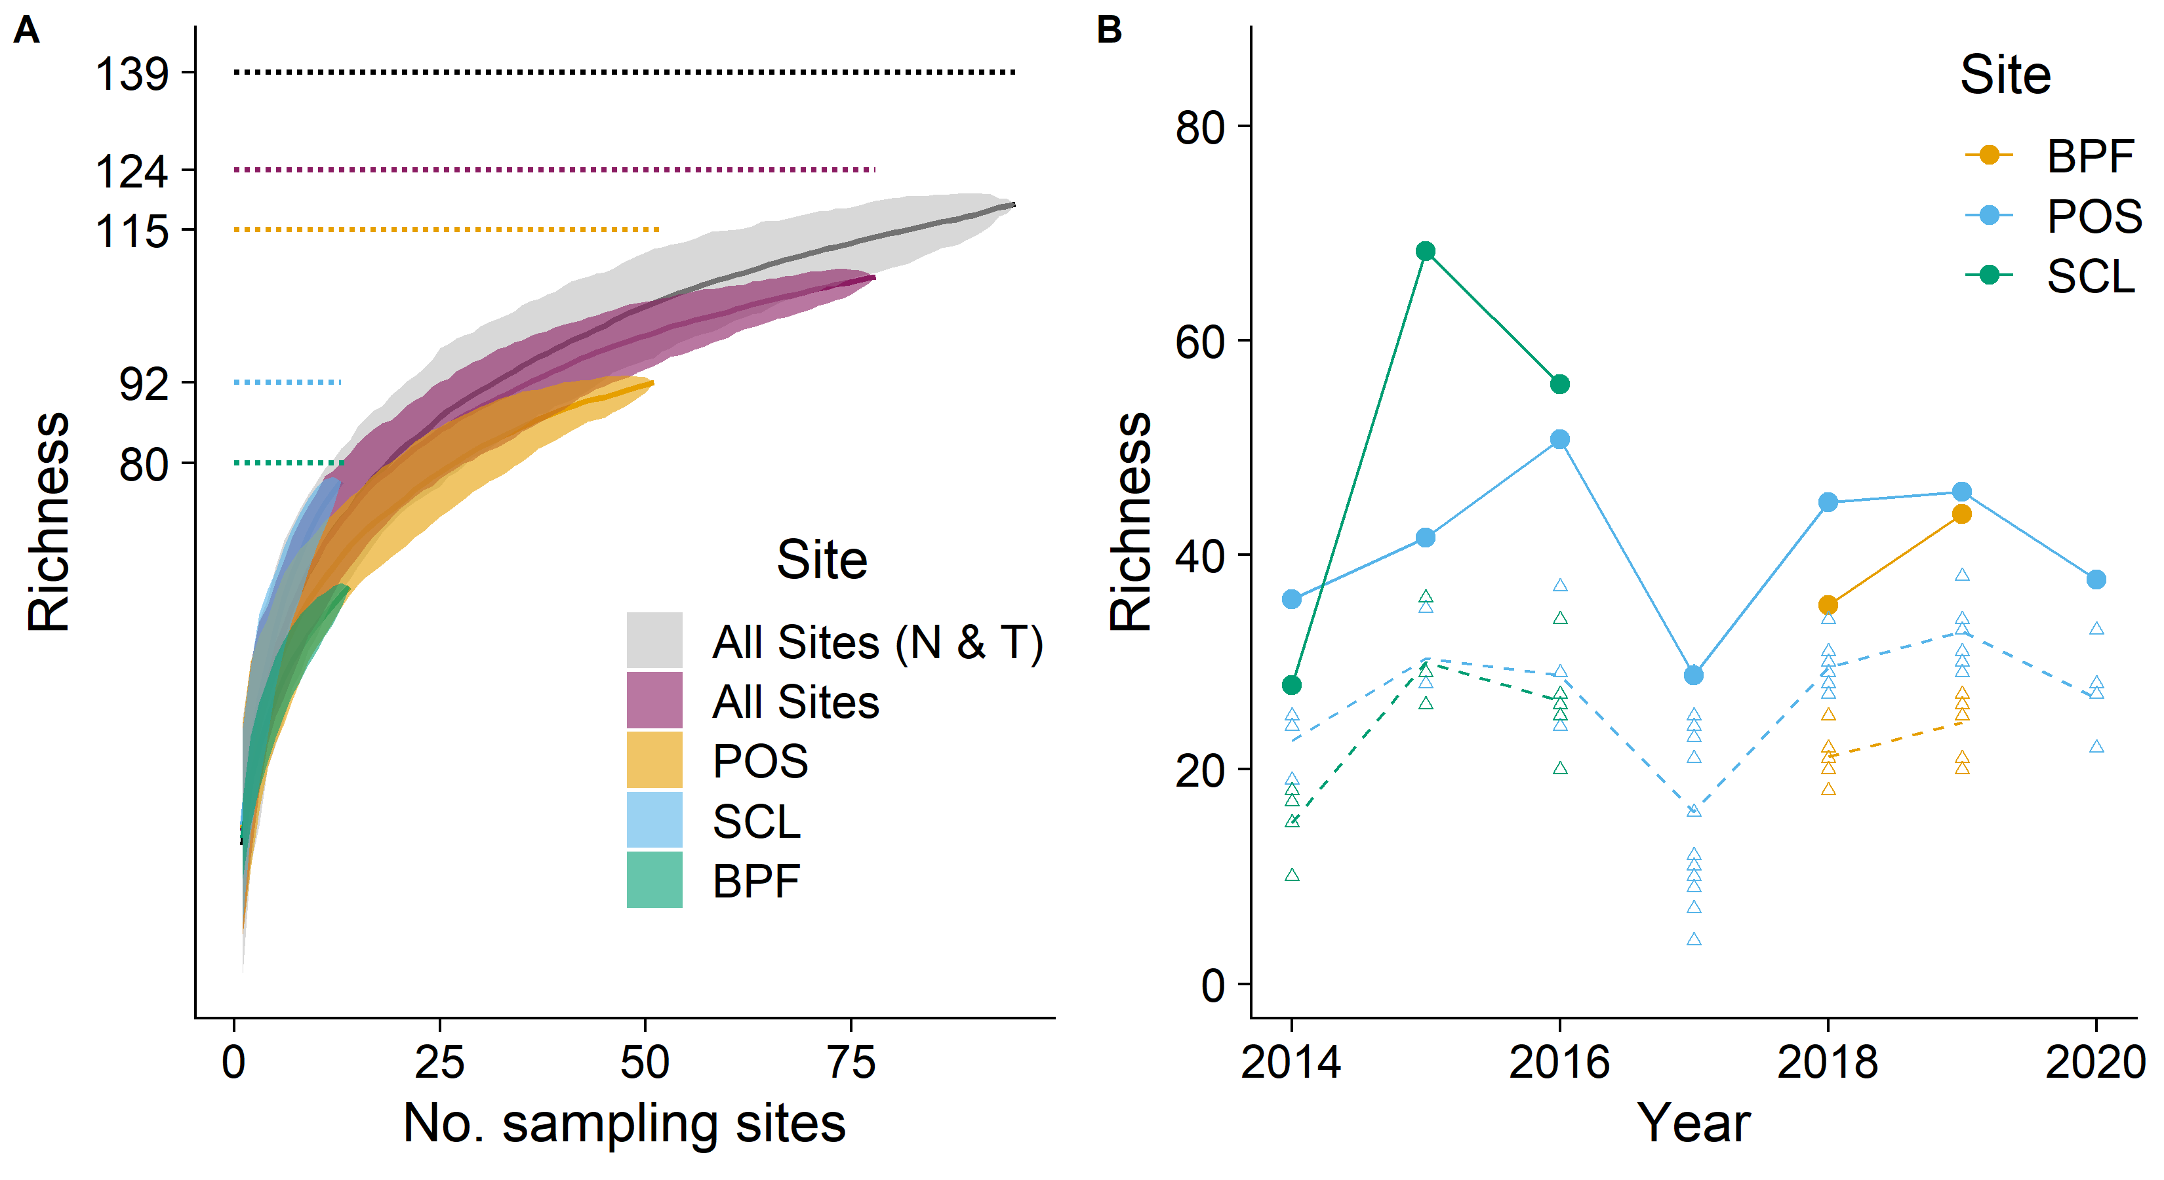

**Fig. 2**

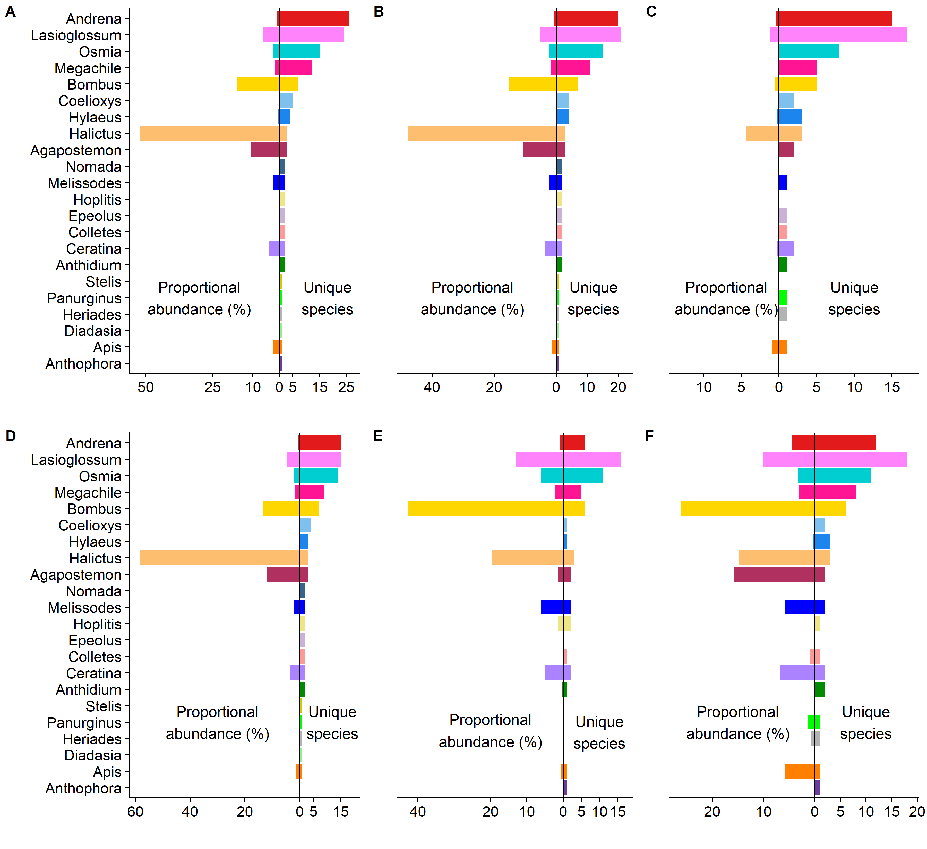

**Fig. 3**

**Fig. 4**

**Fig. 5**

**Supplementary Fig. S1.** Estimated species-level seasonal distributions. Sample sizes displayed are the total number of records for each species. Species displayed are those for which sample sizes were [\ge](https://camo.githubusercontent.com/c2d96728cd1cda8c7998418bbaf71dacc073bf4fbad71ceb03065377d8251e2e/68747470733a2f2f6c617465782e636f6465636f67732e636f6d2f706e672e6c617465783f2535436765) 20. Vertical dashed lines correspond to 21 March, 21 June, and 21 September.

**Supplementary Figure S2.** Estimated genus-level seasonal distributions for parasites: (A) Stelis, (B) Epeolus, and (C) Triepeolus. Beneath each parasite genera are presumed host genera. Sample sizes on the right are the total records for each genus. Vertical dashed lines are 21 March, 21 June, and 21 September. These parasites have low sample sizes limiting accurate estimation.

